SSD202 Development Notes | 01- Dongshan Pi One Development Board Quick Start (original SDK Quick Start)

Mculover666Published at 2021-12-19 16:52:051401 Favorite 3
Category column: SSD202 Article tags: SSD202D linux
copyright
SSD202The column contains this content
1 article0 subscriptions
Subscribe to the column
In this article, I use Ubuntu 18.04, Aliyuan.

1. Dongshan Pi One Development Board
The Dongshan Pi No. 1 development board is the smallest Linux development board jointly promoted by the original chip manufacturer Xingchen Technology:
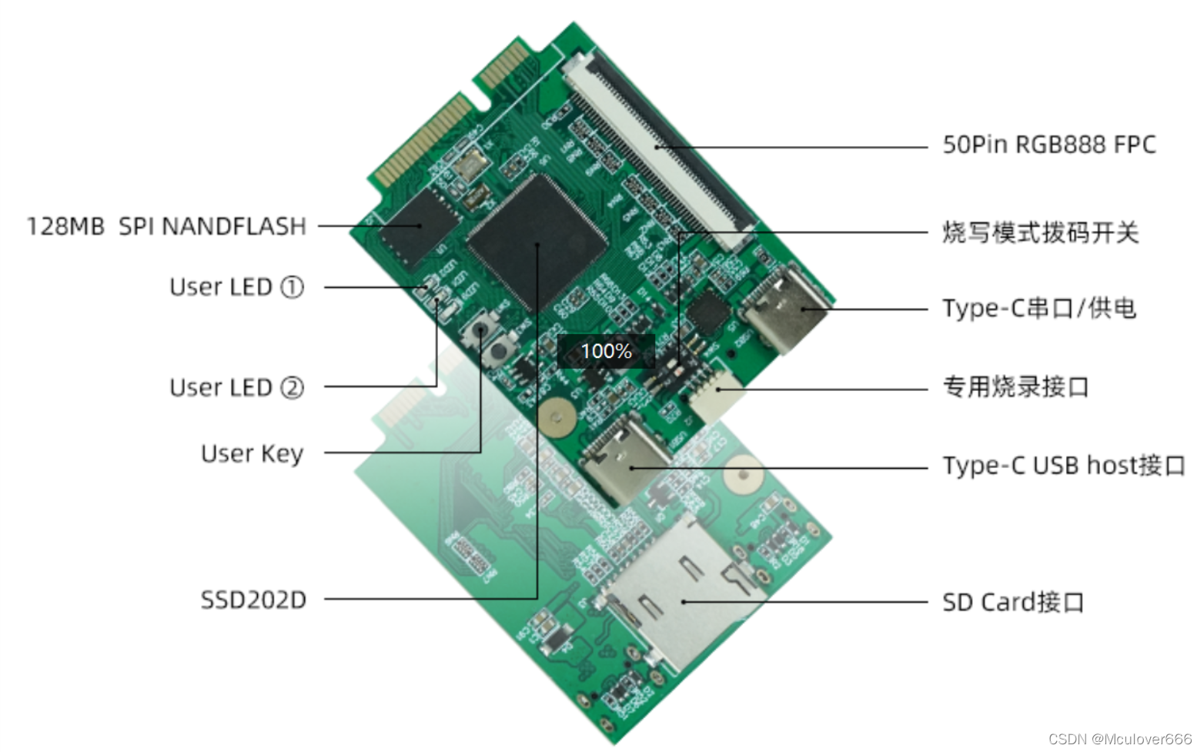
- Main control chip: Star Technology SSD202D built-in 128MB DDR Support H264/H265 decoding Support MJPG encoding
- Storage: Onboard 128MB SPI NAND FLASH chip (Xin Memory Technology XCSP1AAWH-NT) and dedicated SD card interface
- LED light: red x1 means pwr blue and green are user lights.
- Key: Hardware reset button x1 User button x1
- Display: 50Pin FPC RGB888 display output
- Power & Debug: The onboard dedicated USB to TTL chip supplies power to the entire board at the same time.
- usbHost: The USB HOST of the Type C interface supports connecting devices that support the USB protocol.
- Expansion interface: Use the MINI-PCI-E interface to connect to the backplane.

2. SSD202D
SSD201 (64MB DDR2) / SSD202D (128MB DDR3) is a highly integrated SoC based on ARM Cortex-A7 dual-core, which integrates:
- H.264, H.265 video decoder
- JPEG encoder
- Display subsystem: TTL/MIPI display, etc.
- 2D graphics engine
- audio processor
- NOR/NAND Flash interface
  - Support 1/2/4-bit SPI-NOR / NAND (with ECC) flash, with two chip selects
- SDIO 2.0 interface
- Two USB 2.0 ports
- DRAM memory: a DDR integrated inside
- Supports two Ethernet interfaces
- Security engine: support AES/DES/3DES/RSA/SHA-I/SHA-256, support secure boot
- RTC
- Common peripherals
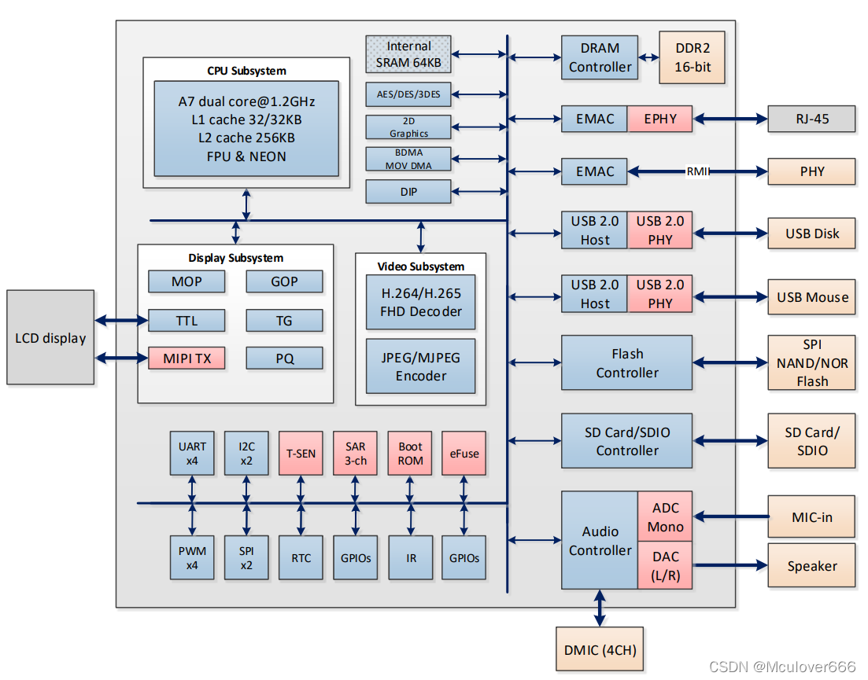
material:
- SSD202 Official Wiki
- dongshanPi Official Wiki

3. Install the necessary packages
sudo apt-get install -y libc6-dev-i386 lib32z1 lib32ncurses5 libuuid1:i386 cmake libncurses5-dev libncursesw5-dev bc xz-utils automake libtool libevdev-dev pkg-config openssh-server repo

Fourth, get the source code
For the source code, we use the repo tool to manage multiple git repositories in a unified manner, which is convenient for one-click access and update.
git clone https://e.coding.net/codebug8/repo.git
mkdir DongshanPiOne-TAKOYAKI && cd DongshanPiOne-TAKOYAKI
../repo/repo init -u https://gitee.com/weidongshan/manifests.git -b linux-sdk -m SSD202D/dongshanpi-one_takoyaki_dlc00v030.xml --no-repo-verify
../repo/repo sync -j4
The source code directory structure after successful acquisition is as follows:

5. Set up the cross-compilation toolchain
Add this line to .bashrc:
export PATH=$PATH:/home/mculover666/dongshanPi-one/DongshanPiOne-TAKOYAKI/gcc-arm-8.2-2018.08-x86_64-arm-linux-gnueabihf/bin
Effective:
source .bashrc
Check arm-linux-gnueabihf-gcc version:
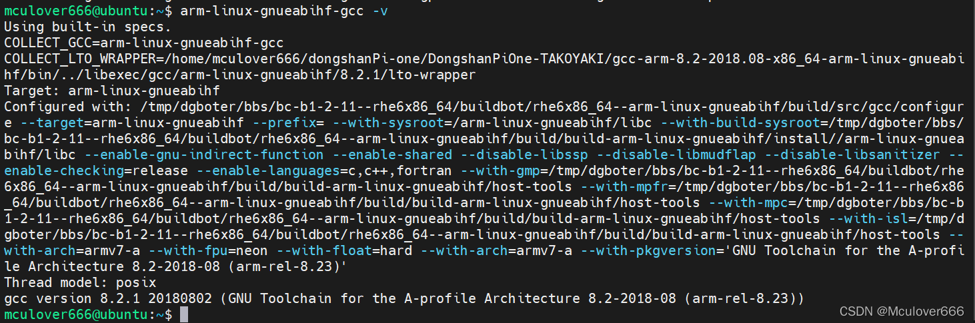

6. Compile and write uboot
Programming uboot requires a programming tool, which is temporarily reserved.

Seven, compile and burn the kernel

1. Compile the kernel
The kernel used by the Dongshan Pi One development board is based on the Linux Kernel mainline version 4.9.84 for adaptation support, and supports some proprietary processing units and other driver modules such as its own controllers.
Temporarily set environment variables:
export ARCH=arm
export CROSS_COMPILE=arm-linux-gnueabihf-
Go to the kernel directory:
cd DongshanPiOne-TAKOYAKI/kernel
Configure compilation:
make infinity2m_spinand_ssc011a_s01a_minigui_defconfig;
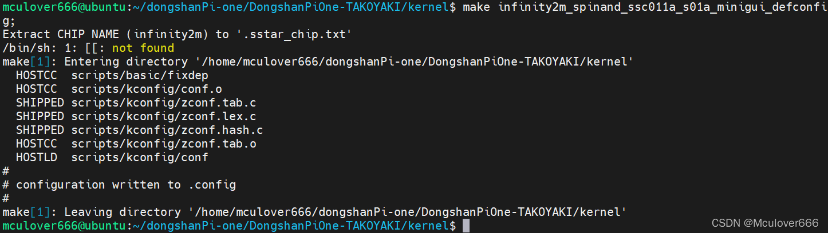
Compile:
make
After the compilation is complete, view the compiled files:
cd arch/arm/boot
Among them uImage.xzis the kernel image we need to burn to nand flash.

2. Burn the kernel in uboot
Burn the kernel to nand via SD card:
fatload mmc 0:1 0x21000000 uImage.xz
nand erase.part KERNEL
nand write.e 0x21000000 KERNEL ${filesize}
nand erase.part RECOVERY
nand write.e 0x21000000 RECOVERY ${filesize}

